You and your family
are invited to
CTHA’s & BTSC’s
Annual Summer
Pot-Luck Picnic
Saturday, August 3rd
11:00 AM - 5:00 PM
Jo West’s Home on Lake Lanier in Dawsonville

Jo has graciously hosted this event for many years and it has become an eagerly anticipated tradition! This is the second year we are bringing Chattahoochee Trail Horse Association and Bent Tree Saddle Club members together for a combined day on the lake. We’ll start with some wet ’n wild fun . . .
take a spin around the lake aboard a jet ski or speed boat, swim off the dock,
or just relax and enjoy the view, lake breezes and social festivities.
At about 1:00, we’ll roundup for our feast to enjoy the bounty of yummy home-cooked delights
and lots of horse and club talk. Weather permitting, we’ll resume activities on the lake.
CTHA RSVP is a must to Bruce Kosins by July 26
email kosins11@yahoo.com
BTSC RSVP is a must to Marianne Torchia by July 26
Phone 770-757-2282 or email maretorch1@gmail.com

The clubs will provide BBQ & chicken tenders, tea, lemonade, water and table service.
We ask that YOU SHOULD BRING:
An appetizer, salad, side dish, or dessert of your choice
Bring plenty to feed our hungry crowd!
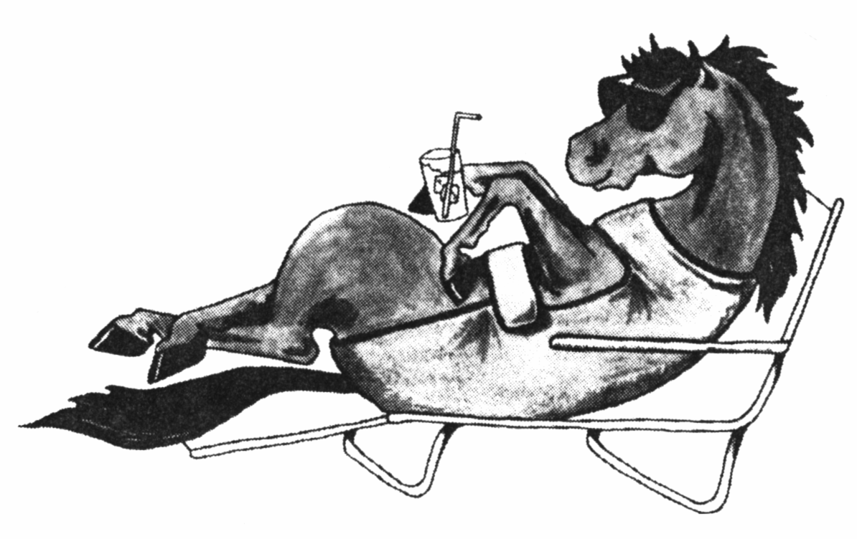
Your own lawn chair and life jacket
if you have one. Jo has some
but not enough to go around.
Swim suit and towel if you want to get wet.
A hearty appetite and lots of horse talk!

DIRECTIONS to 1122 Chestatee Point, Dawsonville, GA 30534

Traveling North on GA 400, go 1 mile past HWY 53 in Dawsonville to the first traffic light.
Turn RIGHT onto HARMONY CHURCH ROAD and go 1 mile.
Turn RIGHT onto NIX BRIDGE ROAD and follow directions from ➔ below.
OR
Traveling South on GA 400, go to HWY 136. Turn LEFT onto HWY 136 and go to 3-way STOP.
Bear RIGHT at stop, go 1 block and turn LEFT onto NIX BRIDGE ROAD. Follow directions from ➔ below.

➔ Go .9 (nine tenths) of a mile on Nix Bridge Road. Turn LEFT on CHESTATEE POINT and go to the STOP sign.
Turn RIGHT at the stop sign (you will still be on Chestatee Point). Go to the very end of the road where two BLACKTOP driveways will be directly in front of you. Jo’s is the BLACKTOP driveway on the right with the
number 1122 painted on the blacktop. If Jo’s driveway if full, park on the street.

